**ISTQB® Podcast Network Application Form**

The ISTQB® Podcast Network brings local and global testing communities together to share knowledge and insight into testing, quality assurance, and quality engineering topics.

The ISTQB® Podcast Network will support eligible podcast series with promotional activities:

* Listing on the ISTQB® website
* Posts on the ISTQB® social media channels
* Authorization to use the official ISTQB® International Podcast Network logo to build visual identification.

Apply to join the ISTQB® Podcast Network by providing the information required below, and submit this application form (and any logo for your Podcast Series) to [podcast.network.lead@istqb.org](mailto:podcast.network.lead@istqb.org).

**Obligations and commitments:**

| **Request/Criteria** | **Are you compliant with this request?** | **Comments** |
| --- | --- | --- |
| The podcast series is organized or recognized by an ISTQB® Member Board, exam provider, accredited training provider, partner organization, or any organization/community in direct collaboration with any of these bodies. | **Yes ⬜ No ⬜** |  |
| The podcast series is in the domain of quality assurance, software testing, or quality engineering. | **Yes ⬜ No ⬜** |  |
| The podcast series includes at least three (3) released episodes at the time of application. | **Yes ⬜ No ⬜** |  |
| There is a development plan for further episodes and a commitment to ensuring a stable and publicly available channel(s). | **Yes ⬜ No ⬜** |  |
| The podcasts will be scheduled and available according to their announced frequency. | **Yes ⬜ No ⬜** |  |
| The podcasts do not need to be aligned directly to the ISTQB® Testing Body of Knowledge or any specific ISTQB® curriculum but they must not include any statement detrimental to the ISTQB® community, principles, or products. | **Yes ⬜ No ⬜** |  |
| The podcast series is not publicizing any specific company, tool, or service. The podcasts will make it clear that ISTQB® is not giving any direct endorsement or validation of any organization, the content, views, recommendations, tools, etc. | **Yes ⬜ No ⬜** |  |
| The podcast provider will include the official ISTQB® Podcast Network logo on the website or delivery channel and where possible in its marketing activities (e.g. social media). | **Yes ⬜ No ⬜** |  |

**Podcast Details:**

|  |  |
| --- | --- |
| **Podcast Name (and acronym if exist):** |  |
| **General Description: (**up to 150 words about the podcast vision, content directions, target audience, objectives) |  |
| **Link to the main channel:** |  |
| **Organizer:**  (Organization) |  |
| **Country:** |  |
| **Contact Name:** |  |
| **Contact E-Mail:** |  |
| **Second Contact Name:** |  |
| **Second Contact E-Mail:** |  |
| **Frequency:** |  |
| **Languages:** |  |
| **Style:**  (e.g. Video, Audio, Hybrid…) |  |
| **Type of Speakers:** (e.g. International, Locals…) |  |
| **Host Organization Website, or any social network channel:** |  |

Notes:

* The ISTQB® reserves the right to review these rules at any time.

Applicants submitting to join the ISTQB® Podcast Network are expected to maintain a professional and impartial stance. Where there is promotion for personal or organizational commercial gain it must be clearly stated that there is a commercial interest (in such an instance your podcast series will be tagged "Sponsored Content" (note, this will also apply to Accredited ISTQB®Training Providers). Additionally, personal images (such as headshots) will not be accepted as logos; all branding should reflect the podcast rather than an individual.

If you are a podcast organizer and you would like to join the ISTQB® Podcast Network, send this form including evidence of recognition by ISTQB® Member Board, exam provider, accredited training provider, partner organization and podcast logo to [podcast.network.lead@istqb.org](mailto:podcast.network.lead@istqb.org).

As soon as your application is accepted you will receive the package with logo in vectors. You can use and publish the following ISTQB® Podcast Network logo on the website or channel and where possible in its marketing activities (e.g. social media):

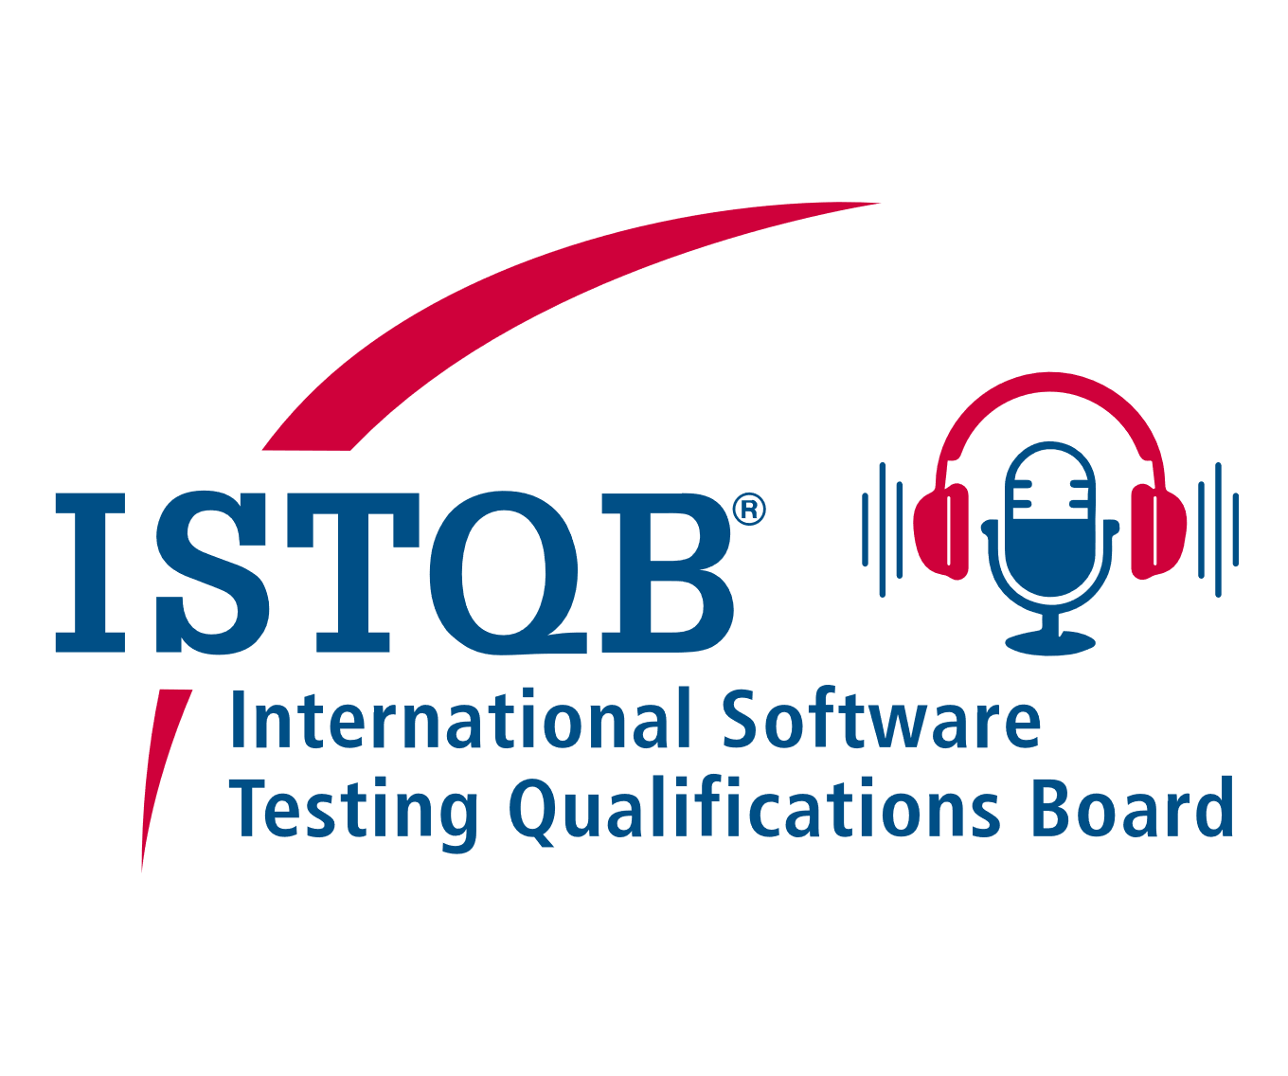

Signature (should be an authorized representative of the podcast organizing body):

Date: ______________________ Location: ________________________

Role: ______________________ Full Name: _______________________

Signature: _______________________________

**Confirmation Form**

*In a case if podcast is organized by ISTQB® Member Board, exam provider, accredited training provider, partner organization there is no need to fill this form, otherwise it should be filled out by any body mentioned above*

We as a support organization, truly believe that the podcast hosted by ____________ keeps the concept are in quality assurance, software testing, or quality engineering.

The podcasts do not aimed at publicizing their company, tool, or service and is not giving any direct endorsement or validation of any organization, the content, views, recommendations, tools, etc.

And finally, they do not include any statement detrimental to the ISTQB® community, principles, or products.

Signature (should be an authorized representative of the ISTQB® Member Board, exam provider, accredited training provider, partner organization):

Date: ______________________ Organization: ________________________

Role: ______________________ Full Name: _______________________

Contact e-Mail: _______________________

Signature: _______________________________